User Manual

for

Profile Generator

CBSE Remodeled assessment system
effective from the Academic session 2017-18

PGM and PGS


36, Dr. R. K. Nagar, Neemuch (M.P.)
Ph: 09425106305, 09425106306 Email-newmake@rediffmail.com
www.cbserc.in; www.net4you.in
Important:
- You need MS Excel installed computer system.
- Macros must be enabled in excel before use.
To enable macros take the following steps
Excel 2007+ > File or Office Button > Excel Options > Trust Center > Trust Center Settings button > Macro Settings >
Set to Enable All Macros.
- For the new settings to take effect, it will be necessary to close Excel and reopen it. A security dialog box should appear beneath the Office ribbon the next time you attempt to run a spreadsheet that contains macros.
- When the notification appears, click the Options button. Choose enable this content from the options that appear to allow macros to run within the current spreadsheet. Click OK to close the window.
Excel 2003 > Tools > Options > Security > Macro Security must be set to Low.

- Unzip the file received through email using WinRAR.
- You will get an excel file named PGS/PGM 2017-18.
- Now open the PGS 2017-18 or PGM 2017-18 File.
This is the home screen of PG module.
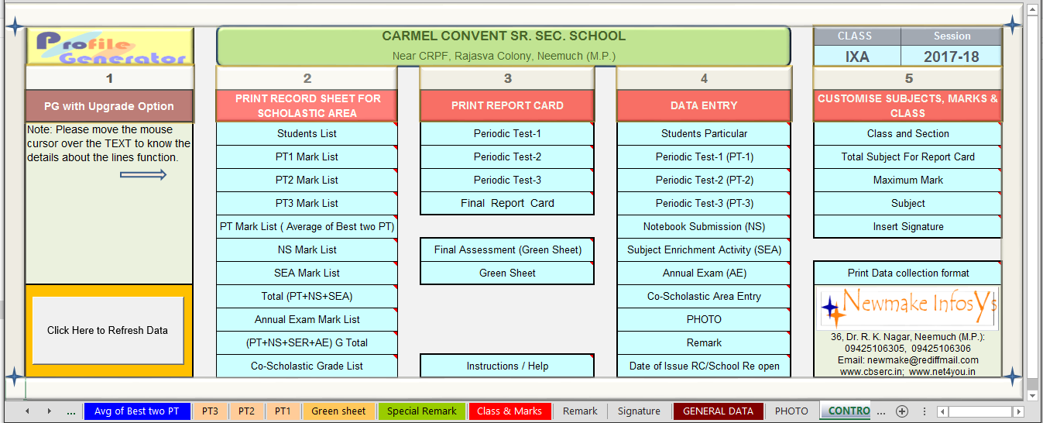
i. Column no 2nd and 3rd links will allow you to manage various reports and report card in the hard and soft format.
ii. You have to use links of column 4 for data entry work, i.e. students’ particular, marks of various assessments and grade for co-scholastic area.
iii. Links given in 5th column are useful to customize subject, class, maximum marks, total no of subjects.
Please move the mouse cursor over the TEXT of each column to know the details about the lines function.
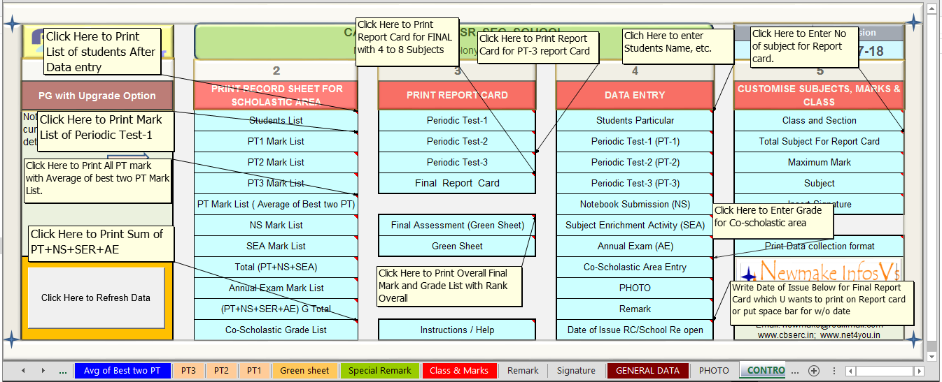
- Now click the any on line of column 05 of control page
Class and Section or Maximum Mark or Total Subject for report card

Following screen of PG module will appear, here you can customize the class & section, Total number of subjects required in the report card, maximum marks and Date to issue RC or reopen school.
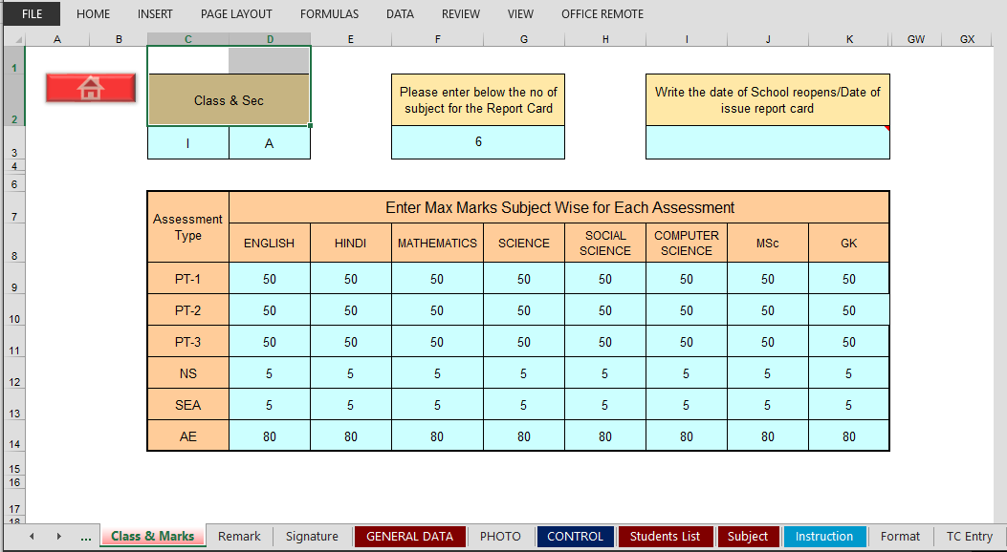
Use Red Home Button for back to control sheet.

- To customize subject offered by you please click subject button from 5th column of control.

- Here you can edit/change title of the subjects appear in mark list and students subject.
This is the Subject screen of PG module
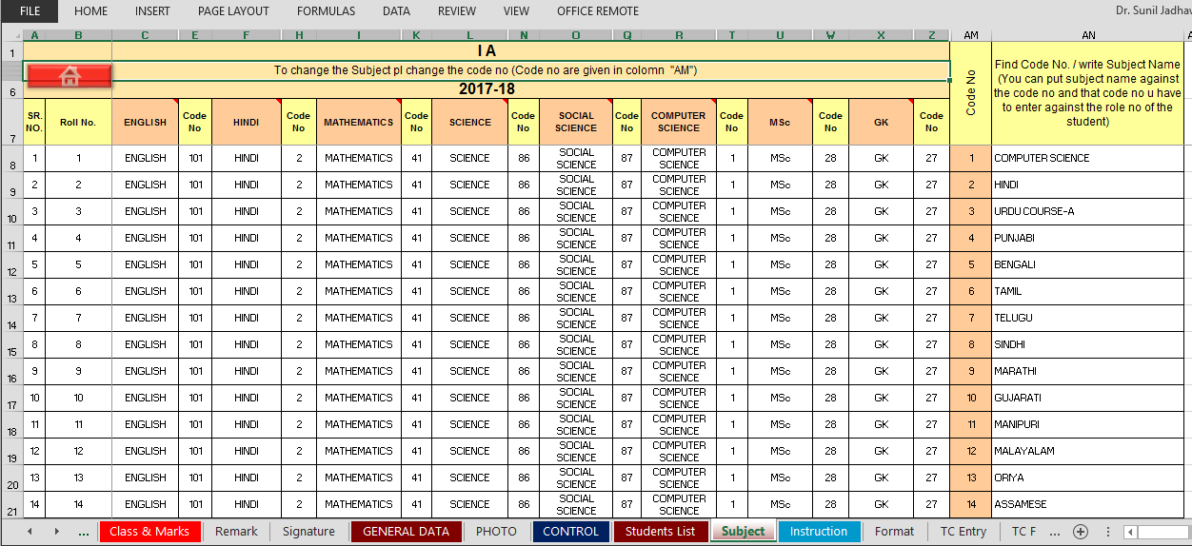
You have to change code no against each roll no, subject wise code no’s are given column AN of the subject sheet.
To change the Subject title in different please edit/write the subject name in the 7th Row of the subject sheet.

Use Red Home Button for back to control sheet.

- Now Click students particular of control (4th column )

This is the Data entry screen of PG module
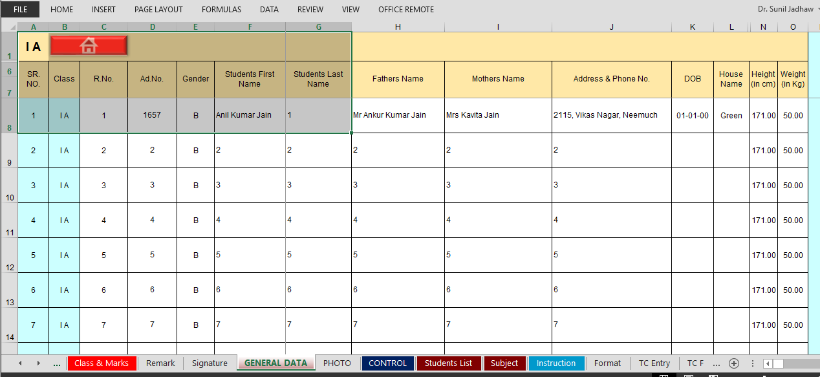
Here please enter column wise information’s of the class students or copy and paste the data from other excel sheet column wise.

Use Red Home Button for back to control sheet.
- To enter marks obtained in various test/exam held through the session click the appropriate line fourth column of control page Periodic Test (PT-1) OR Periodic Test (PT-2) OR Periodic Test (PT3) OR Annual exam (AE) OR Notebook submission (NS) or Subject enrichment activity (SEA) or Co scholastic area entry, here please enter marks obtained by

- This is the Data entry screen of PG module for PT1 and same type for PT2 to AE
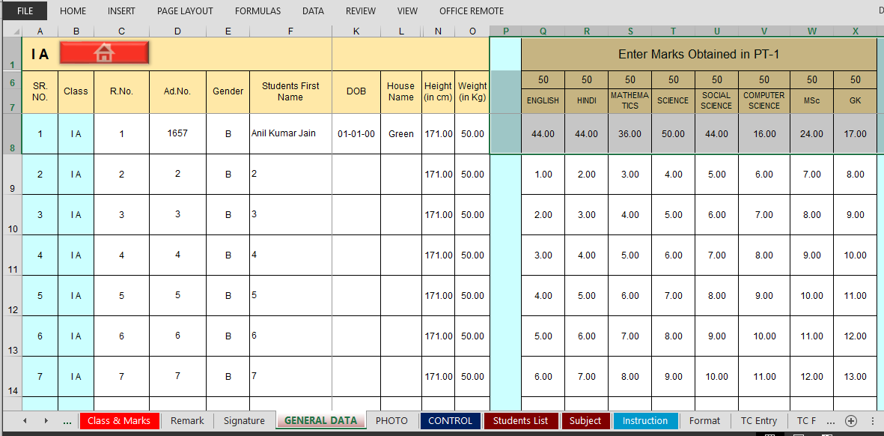
Pl enter marks obtained and save using ctrl S.
Note 1. Use one PG file for one section
2. For Updating of Application you can copy and paste all the data entered in white cells of the General data sheet.

9. Marks entry details for co scholastic area and activity
Here please enter grade only i.e. A, B, C, D, or E
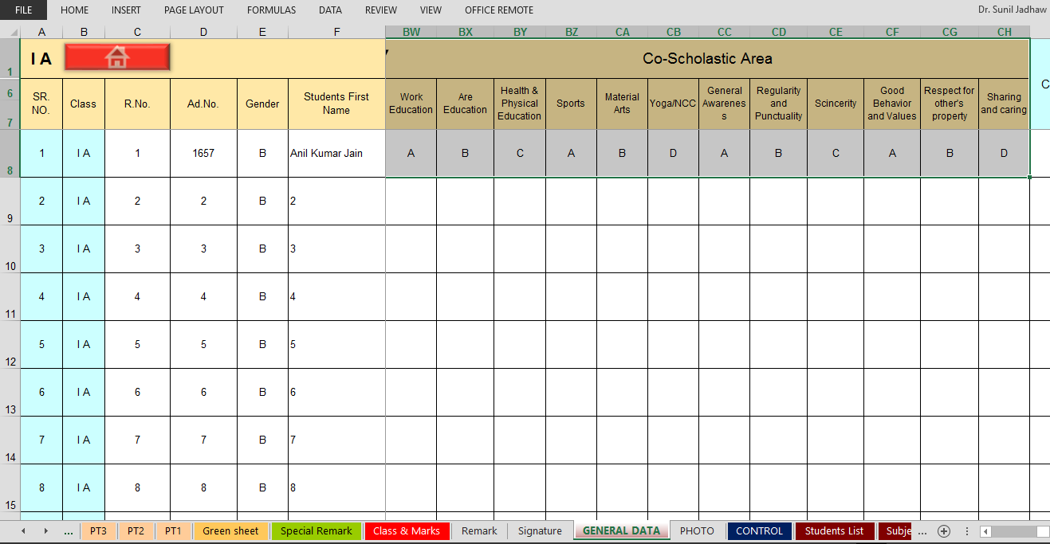

Use Red Home Button for back to control sheet.

10. After entering data you can take printouts of various report class wise for crass checking and office record. As given below for PT1 to PT-3 etc. you have to click 1st columns different links.
Following type sample reports will generate
- Sample mark list report For Periodic Test-1(PT-1)
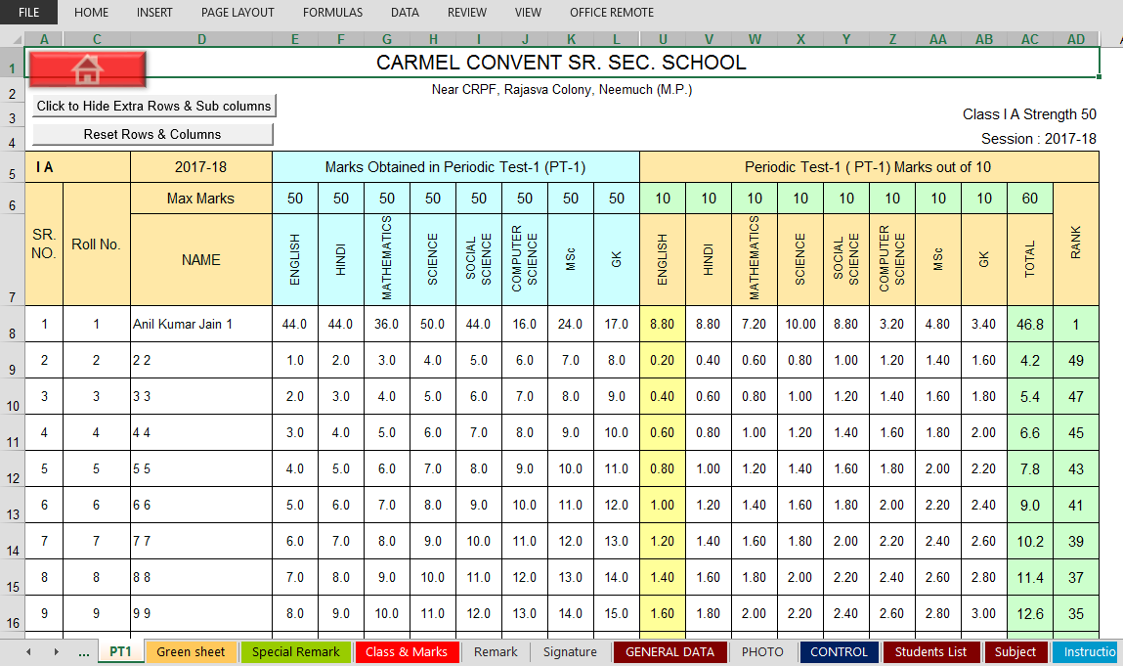
- Sample mark list report For Periodic Test-2 (PT-2)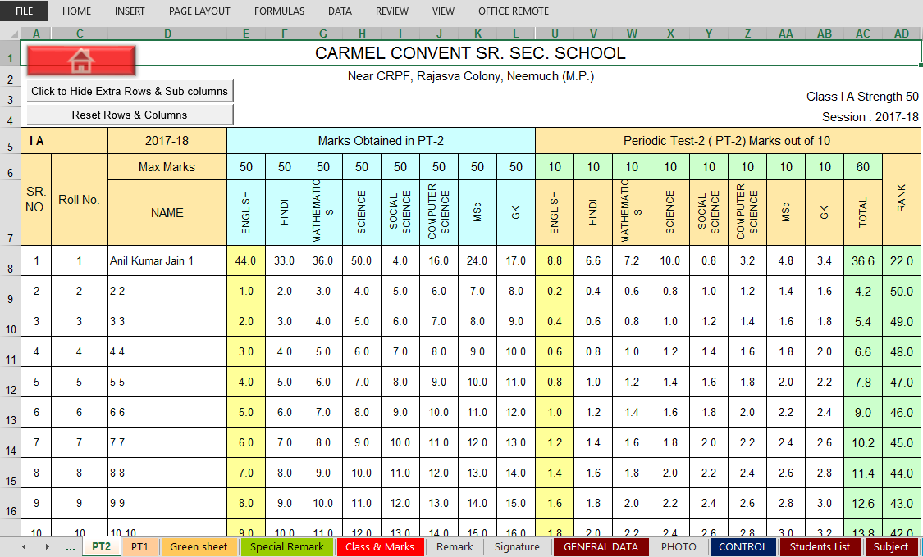
- Sample mark list report For Periodic Test-3(PT-3)
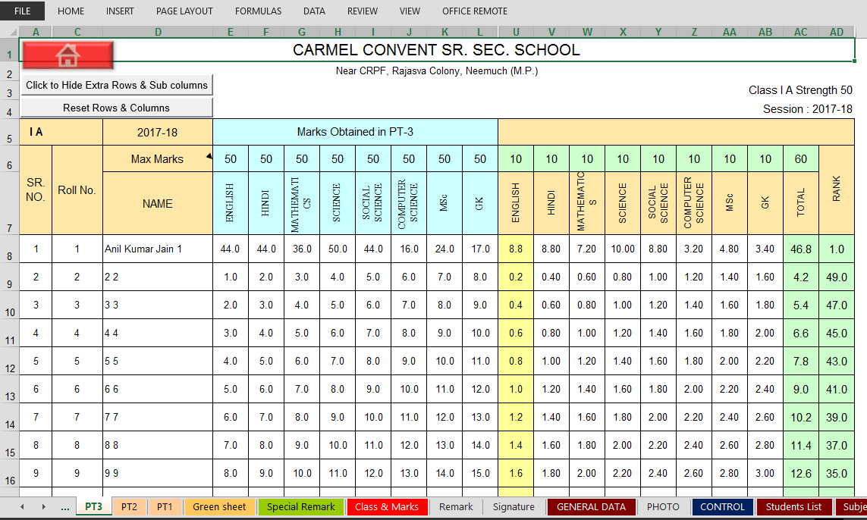
- Sample mark list report for Best of two Periodic Test
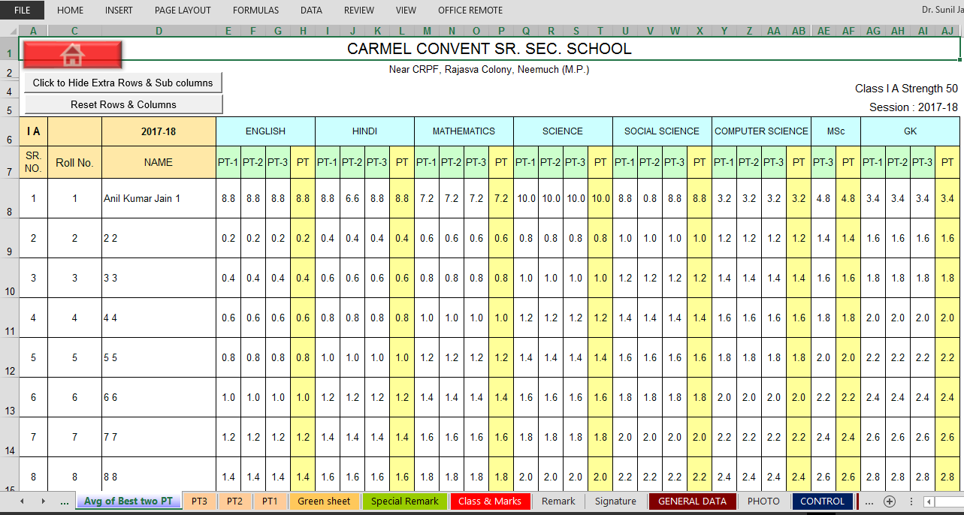
- Sample mark list report for Annual exam
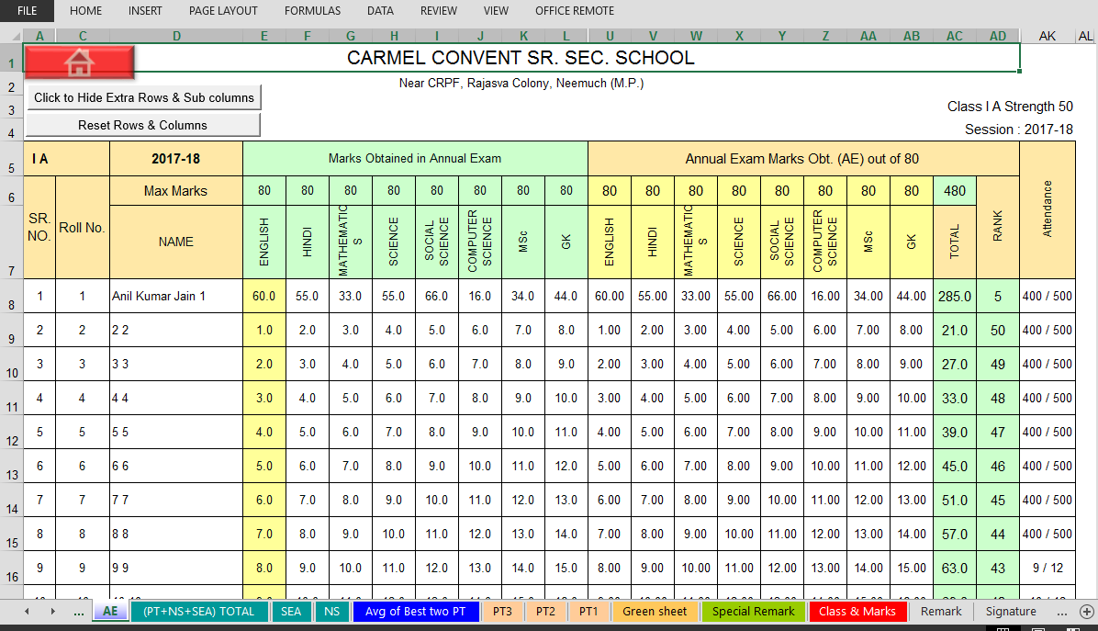
- Sample mark list report for (PT+NS+SEA+AE) GT
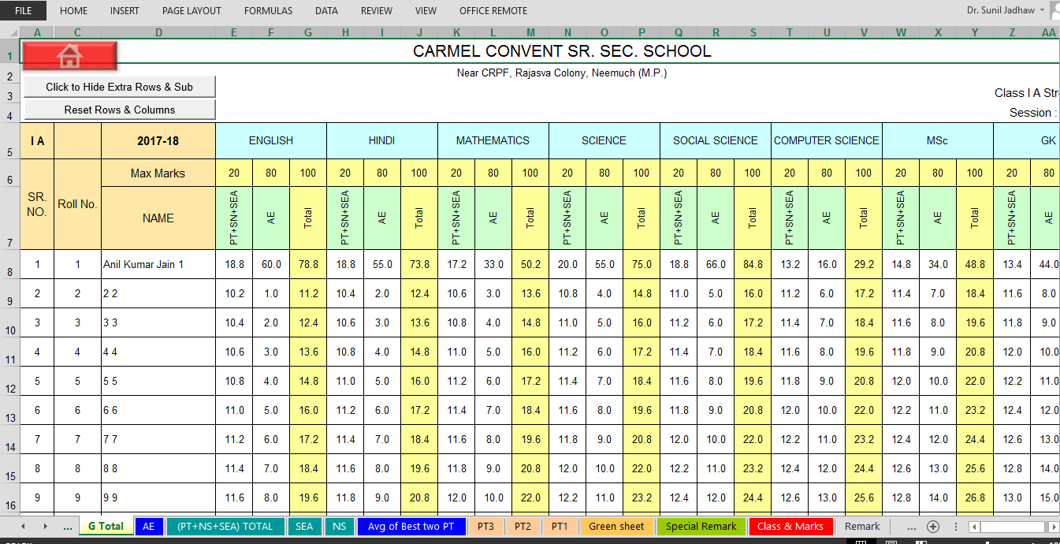
- Sample mark list report Overall Result
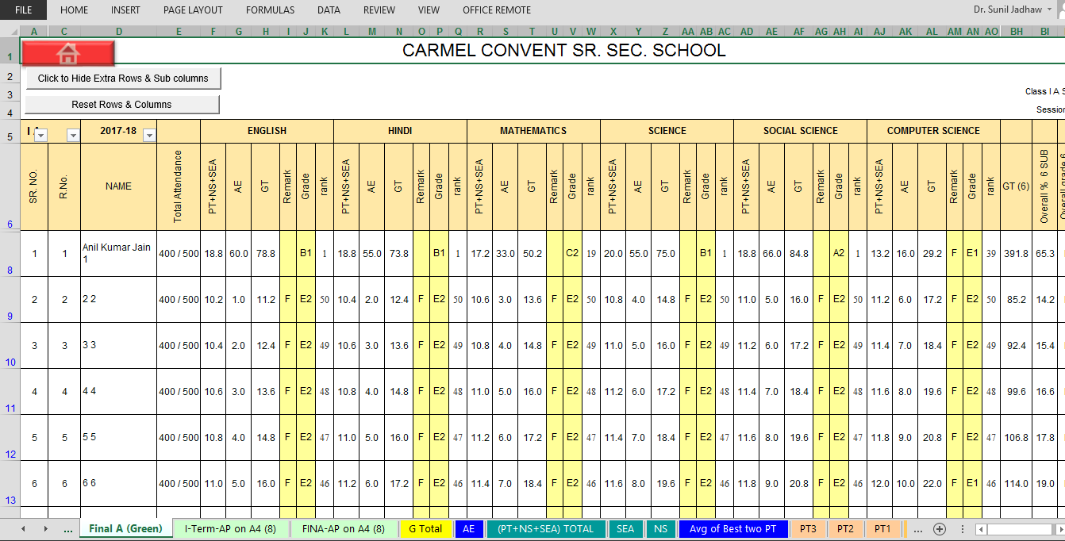

- Sample mark list report Subject wise Green Sheet
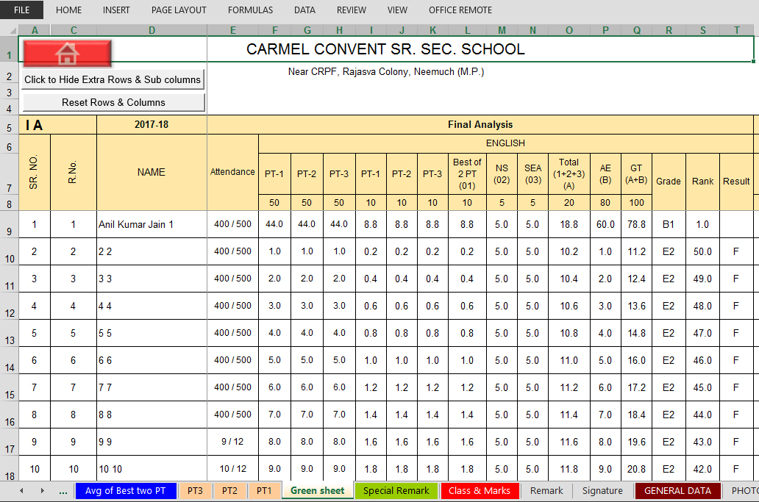
- Sample mark list report Overall Result
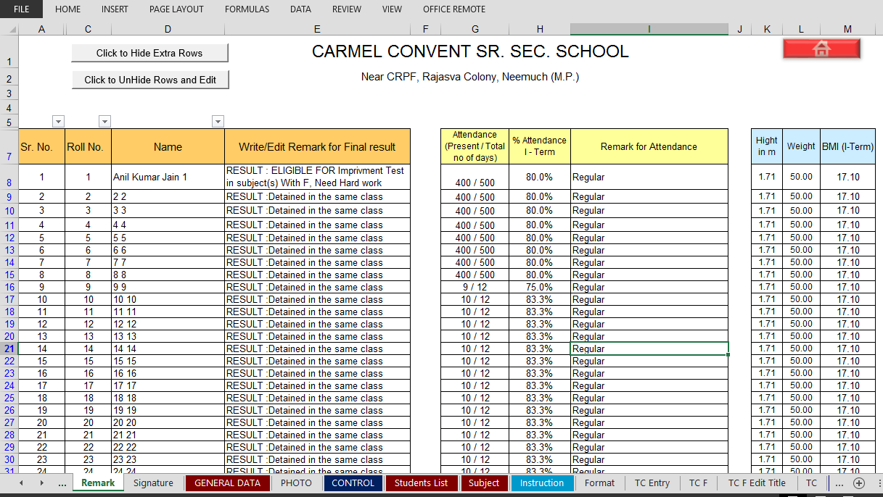
- To insert photo in the report card pl follow the instructions given in sheet photo.
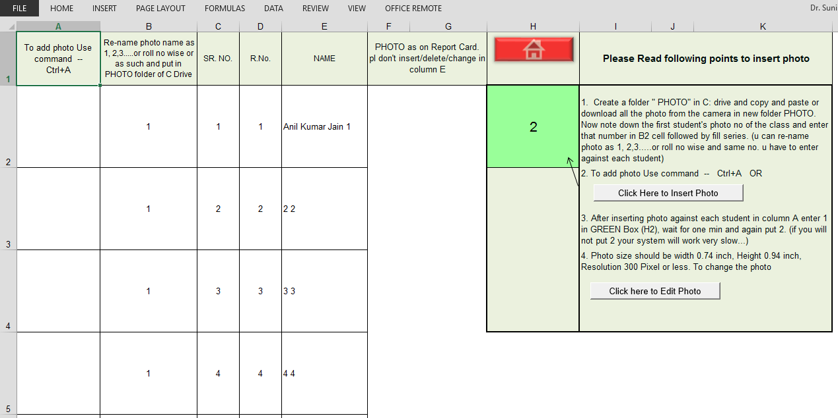
- To insert signature of the principal
Put scanned signature in J5 box and put 1 in L5 box and enter, after 20 second again put 2 in the L3 box.
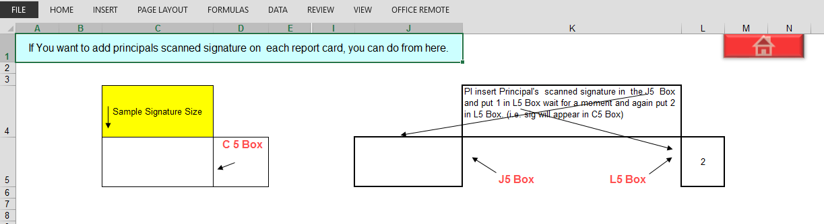

- To print Report card
You have to click 3rd columns different links to print PT-1, PT-2, PT-3 and annual (Final) report card.
Following type sample report card will generate

